INF1103 Terminal and Git command:
Initialize git repository: git init
Check repo status: git status
Expected output is:
- On Branch Master
No commits yet
- Nothing to commit
Add python file to repository: git add modular_auditor.py
To add everything in the current folder at once: git add.
Commit (can use the vs short cut and type message or type out the command):
git commit -m “Adding Lab 1 file”
To push it up: git push / git push origin master
To get to the specific file to run the program: cd INF1103/”Lab 5” (example)
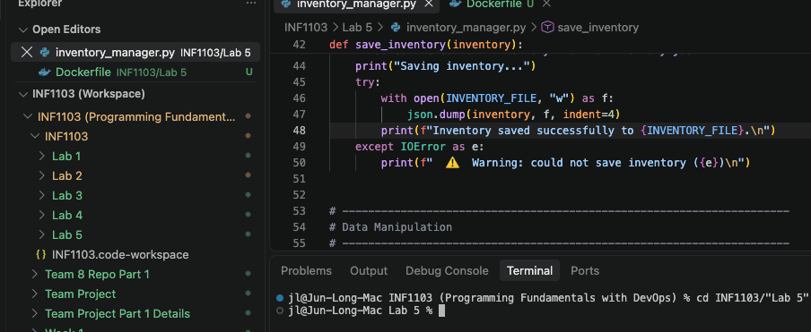
View git history: git log
Check difference in the repository: git diff

Docker Environment:
- Used as a blueprint for creating containers
- A container is a running instance of an image
- A docker file can contain instructions to build an image
Mount and run:
To tell docker to temporarily “link” your local folder inside the running container so the container can read and run your script.
The following command run it with a volume mount, so inventory.json persists on my Mac instead of disappearing when the container exists.
Command: docker run -- rm -it -v “$(pwd):/app” inventory-manager
- -- rm: Auto destroys and cleans up the container once it finishes running the script
- -it: Starts a bash shell inside the container and gives you a interactive terminal where you can type commands
- - v $(pwd): Volume mount. Maps the current local directory (pwd) directly inside the container at the directory path.
- Inventory-manager: Instructs the container to run the local python script
Create custom docker blueprint:
- Create a Dockerfile in vs and paste the following code (change the naming based on the project/lab requirements)
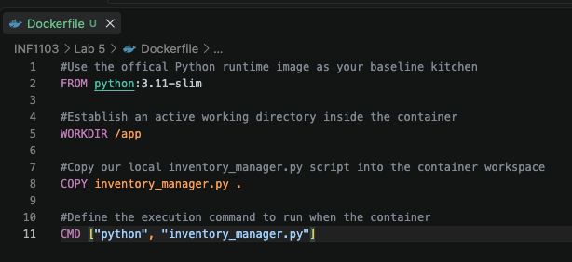

Building custom image: (docker mount and run)
Command: docker build -t inventory_manager .
- Docker build read the local docker file and compile a new image
- - t inventory-manager, it tag (names) your custom image so you can easily reference to it
- . The dot is crucial! It tells docker to look for the coker file inside the current directory.
Expected output should look like this:
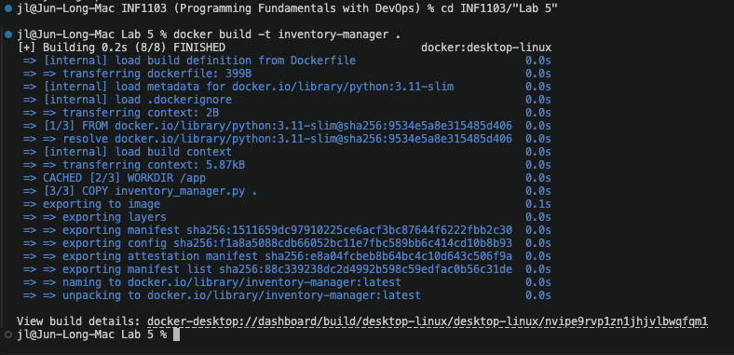
Command for evidence that the image was successfully or lists all the docker images currently stored on the machine:
- docker images
Expected output:
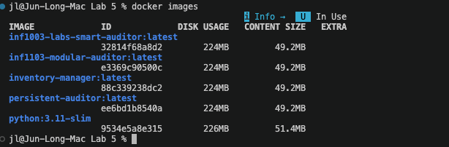

Run your custom container: (proof that the images run successfully with a screenshot showing the program accepting input and producing results)
Command: docker run --rm -it inventory-manager
- i – keep standard input open
- t – allocate a terminal
- (it) – allows user to type values into input()
Expected output:
